Meet soni
Assignment module 2 : Installation and Maintenance of Hardware and Its
Section 1: Multiple Choice Section
1. Which of the following precautions should be taken before working on computer hardware?
a) Ensure the computer is plugged in to prevent electrostatic discharge.
b) Wear an anti-static wrist strap to prevent damage from electrostatic discharge.
c) Work on carpeted surfaces to prevent slipping.
d) Use magnetic tools to handle components more easily
ANSWER = b) Wear an anti-static wrist strap to prevent damage from electrostatic discharge.
2.What is the purpose of thermal paste during CPU installation?
- To insulate the CPU from heat.
- To provide mechanical support for the CPU.
- To improve thermal conductivity between the CPU and the heat sink.
- To prevent the CPU from overheating.
ANSWER= c) To improve thermal conductivity between the CPU and the heat sink.
3. Which tool is used to measure the output voltage of a power supply unit (PSU)?
a) Multimeter
b) Screwdriver
c) Pliers
d) Hex key
ANSWER=a) Multimeter
4. Which component is responsible for storing BIOS settings, such as date and time, even when the computer is powered off?
a) CMOS battery
b) CPU
c) RAM
d) Hard drive
ANSWER=a) CMOS battery
Section 2: True or False
5. True or False: When installing a new hard drive, it is essential to format it before use.
6. True or False: A POST (Power-On Self-Test) error indicates a problem with the CPU.
7. True or False: It is safe to remove a USB flash drive from a computer without ejecting it first.
ANSWER = 5. True
6. False
7. False
Section 3: Short Answer
8. Describe the steps involved in installing a new graphics card in a desktop computer.
ANS=. Power Down and Unplug
• Shut down the computer completely.
• Unplug the power cable and all peripherals.
• Press the power button once (while unplugged) to discharge residual electricity.
2. Open the Case
• Remove the side panel of the CPU cabinet using a screwdriver.
• Place the case on a flat, non-carpeted surface.
3. Ground Yourself
• Wear an anti-static wrist strap or touch a metal part of the case to discharge static electricity.
4. Locate the PCIe Slot
• Identify the PCI Express x16 slot on the motherboard — this is where the graphics card goes.
5. Remove Expansion Slot Cover
• Unscrew and remove the metal bracket on the back of the case that aligns with the PCIe slot.
6. Insert the Graphics Card
• Align the card’s connector with the PCIe slot.
• Firmly press it down until it clicks into place.
• Secure the card to the case with a screw.
7. Connect Power Cables (if needed)
• High-end GPUs require extra power.
• Connect 6-pin or 8-pin PCIe power connectors from the PSU to the card.
8. Close the Case and Reconnect
• Reattach the side panel.
• Plug in the power cable and peripherals.
9. Boot and Install Drivers
• Power on the PC.
• Install the latest graphics drivers from the manufacturer’s website (e.g., NVIDIA or AMD).

9. What is RAID, and what are some common RAID configurations?
ANS=
RAID stands for Redundant Array of Independent Disks. It’s used in servers, desktops, and storage systems to:
• Increase performance by distributing data across multiple drives.
• Provide fault tolerance by duplicating or protecting data.
• Expand storage capacity by combining drives into one logical volume.
There are hardware-based and software-based RAID systems. Hardware RAID uses a dedicated controller, while software RAID is managed by the operating system.
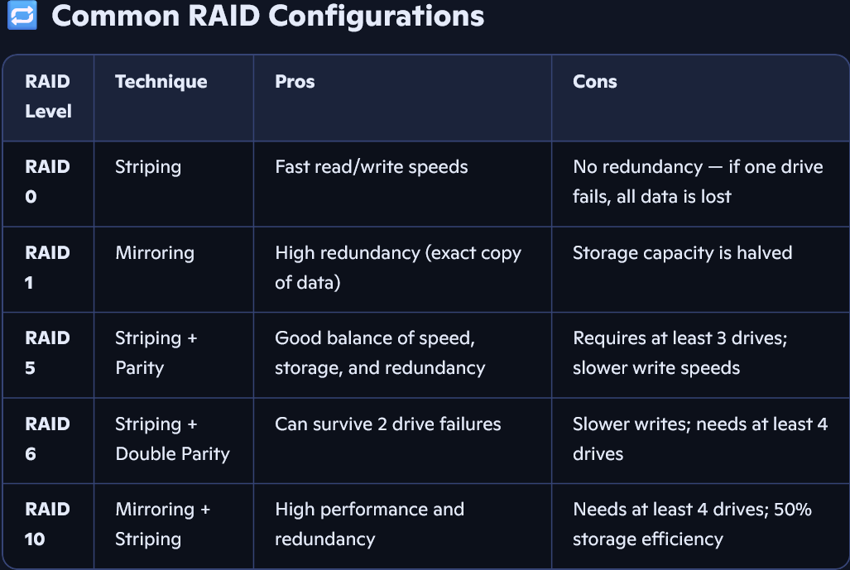
Section 4: Practical Application
10. Demonstrate how to replace a CPU fan in a desktop computer
ANS= 1. Power Down and Unplug
• Shut down the computer.
• Unplug the power cable and all peripherals.
• Press the power button once (while unplugged) to discharge any residual electricity.
2. Open the Case
• Use a screwdriver to remove the side panel of the CPU cabinet.
• Place the case on a clean, flat surface.
3. Ground Yourself
• Wear an anti-static wrist strap or touch a metal part of the case to discharge static electricity.
4. Locate the CPU Fan
• The CPU fan is mounted on top of the CPU, usually attached to a heat sink.
• It’s connected to the motherboard via a small 3-pin or 4-pin connector.
5. Disconnect the Fan Cable
• Gently unplug the fan’s power cable from the motherboard header labeled CPU_FAN.
6. Remove the Old Fan and Heat Sink
• Depending on the mounting system (clips, screws, or push pins), carefully release or unscrew the fan and heat sink.
• Lift it off gently — don’t force it.
7. Clean the CPU Surface
• Use isopropyl alcohol and a lint-free cloth to clean off old thermal paste from the CPU surface.
8. Apply New Thermal Paste
• Apply a small pea-sized drop of thermal paste to the center of the CPU.
• This ensures proper heat transfer between the CPU and the new cooler.
9. Install the New CPU Fan
• Align the new fan and heat sink over the CPU.
• Secure it using the appropriate mounting method (clips, screws, or push pins).
• Plug the fan’s power cable into the CPU_FAN header on the motherboard.
10. Close the Case and Reconnect
• Reattach the side panel.
• Plug in the power cable and peripherals.
• Boot up the system and check BIOS or software to confirm the fan is running properly.
Section 5: Essay
11. Discuss the importance of regular maintenance for computer hardware and provide examples of maintenance tasks.
Maintaining your computer hardware isn’t just about keeping things clean — it’s about preserving performance, reliability, and safety. Here’s why it’s crucial:
• Enhanced Performance: Dust buildup can cause overheating, slowing down your system. Cleaning fans and vents helps maintain speed and responsiveness.
• Increased Reliability: Regular checks help catch failing components early, reducing the risk of sudden crashes or data loss.
• Improved Security: Updating firmware and drivers can patch vulnerabilities that hackers might exploit.
• Data Protection: A well-maintained system is less likely to suffer from hardware-related data corruption or drive failure.
• Extended Lifespan: Preventive care reduces wear and tear, helping your computer last longer without needing costly repairs.

🧼 Examples of Maintenance Tasks
Here are practical tasks you can perform regularly:
1. Physical Cleaning
• Use compressed air to clean dust from fans, vents, and the motherboard.
• Wipe screens and keyboards with microfiber cloths and isopropyl alcohol.
2. Cable and Connection Checks
• Ensure all internal and external cables are securely connected.
• Check for frayed or damaged wires.
3. Drive Maintenance
• Run disk cleanup and defragmentation (for HDDs).
• Use tools like CHKDSK to scan for bad sectors.
4. Software and Firmware Updates
• Update BIOS, drivers, and operating system patches.
• Remove unused programs and startup items to boost performance.
5. Backup and Storage Checks
• Regularly back up important data to external drives or cloud storage.
• Monitor storage space and delete unnecessary files.
6. Temperature Monitoring
• Use software to monitor CPU and GPU temperatures.
• Replace thermal paste if temperatures are consistently high.
7. Power Supply and Battery Health
• Check PSU output with a multimeter.

